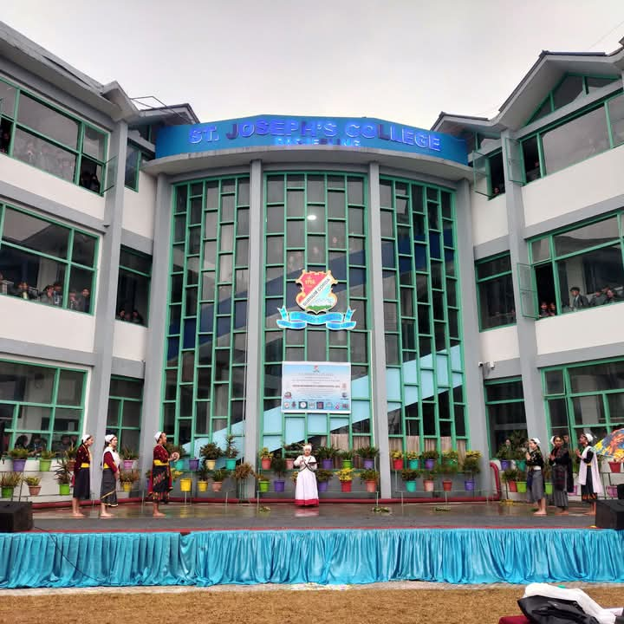
Participation in Inter-Department Dance Competition
Date: 7th March, 2025
Number of Participants: 10 (BCA and Computer Science)
Students of the Department of Computer Science and Application actively participated in the Inter-Department Dance Competition organized by the college’s Cultural Committee. The participants performed a traditional 'Rai Dance,' which beautifully showcased the rich cultural heritage of the Rai community.
Their performance was well-received and applauded for its authenticity and coordination. This participation highlighted the department’s commitment to promoting inclusivity, cultural diversity, and holistic student development through active involvement in extracurricular activities.

